Asia-China-Coin-Bridge-Mould-Coole 5:472, no. 6703 similar

weight:128 gm.; size : length 8.3 cm*width 5.4cm

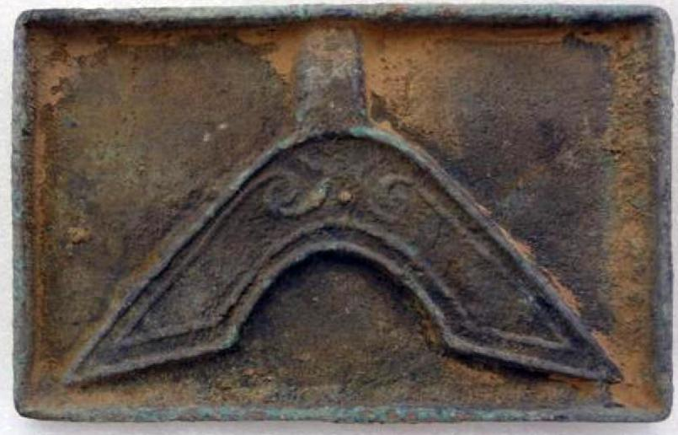 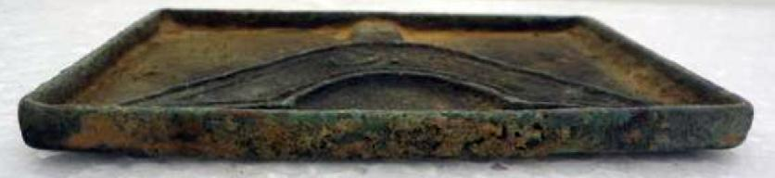 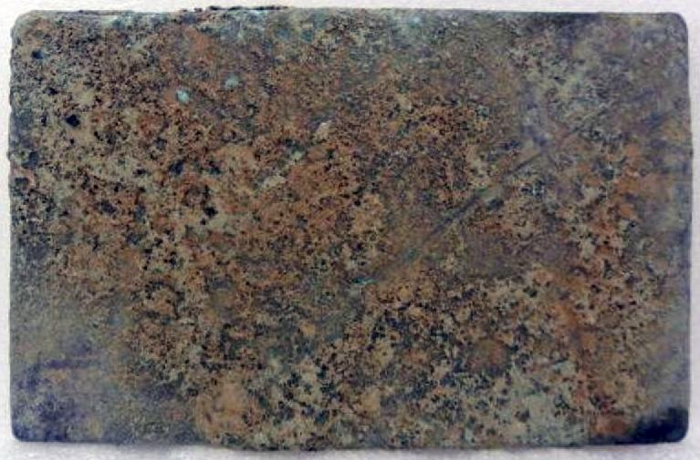

Order details Printer friendly page

Sold by

[lengxue](http://myworld.ebay.com/lengxue) ( [27](http://feedback.ebay.com/ws/eBayISAPI.dll?ViewFeedback&userid=lengxue)  )

+ Show additional actions

Delivery package 1 of 1

Estimated delivery Wednesday, Jan 8, 2014 - Thursday, Jan 16, 2014

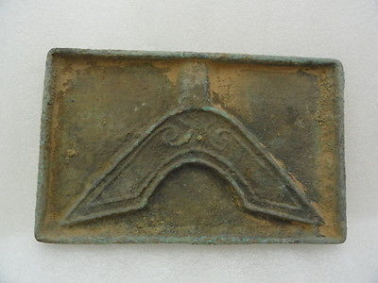

[Oriental Asian Chinese bronze pattern tools of the trade bridge mould,classical](http://www.ebay.com/itm/141147737221)

Item price

$9.99

Quantity

1

Item number

141147737221

Shipping service

ePacket delivery from China

[Leave feedback](http://feedback.ebay.com/ws/eBayISAPI.dll?LeaveFeedbackShow&useridfrom=802-867&useridto=lengxue&item=141147737221&transactid=905211194004) [Contact seller](http://contact.ebay.com/ws/eBayISAPI.dll?FindAnswers&frm=3998&iid=141147737221&redirect=0&requested=lengxue) [Return item](http://return.ebay.com/ws/eBayISAPI.dll?ResolveReturn&eventName=viewSelectedItem&TransactionId=905211194004&ItemId=141147737221)

### Shipping address

Ralph J Coffman Jr  
149 Atlantic Ave   
Swampscott MA 01907-2427  
United States

Phone number  
781 584 7091

### Order total

Subtotal $9.99

Shipping $10.00

#### Total

## $19.99

[View PayPal transaction](http://payments.ebay.com/ws1/eBayISAPI.dll?IntermediateResolutionInfo&itemid=141147737221&transId=905211194004&pn=UnifiedCheckoutSummaryRedirect2PP&qs=itemid%3D141147737221%26transId%3D905211194004%26buyerorseller%3D0%26)

### Order information

Order placed on  
Friday, Dec 27, 2013

Having a problem with this purchase?  
[Resolve problem](http://res.ebay.com/ws/eBayISAPI.dll?ResolutionCenter)

Payment method   
PayPal

Payment date  
Friday, Dec 27, 2013